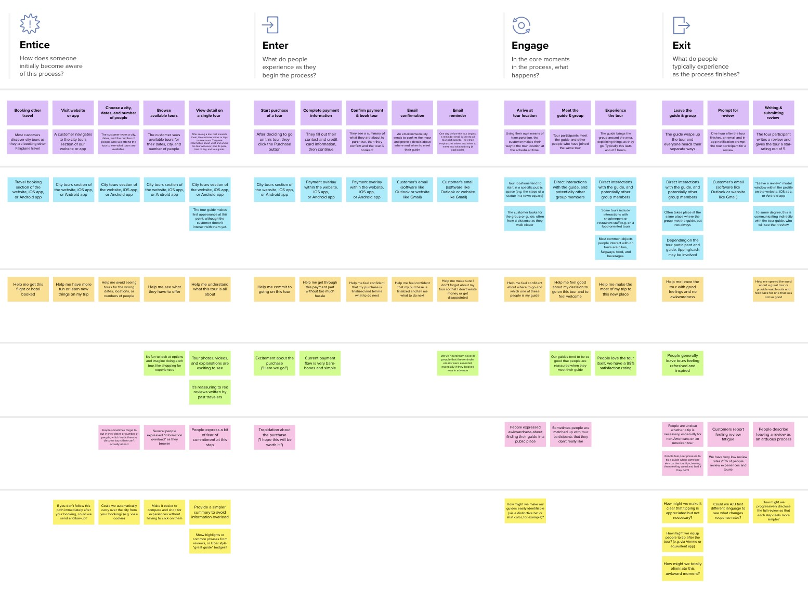

**Template**



✴

**Document an existing experience**

**TIP**

As you add steps to the experience, move each these “Five Es” the left or right depending on the scenario you are documenting.

Narrow your focus to a specific scenario or process within an existing product or service. In the **Steps** row, document the step-by-step process someone typically experiences, then add detail to each of the other rows.

INVENTORY

**Only registered or authorized user can be able to login into the application**

|  |  |  |  |  |  |
| --- | --- | --- | --- | --- | --- |
| **SCENARIO**  **Browsing, booking, attending, and rating a local city tour** | **Entice**  How does someone initially become aware of this process? | **Enter**  What do people experience as they begin the process? | **Engage**  In the core moments in the process, what happens? | **Exit**  What do people typically experience  as the process finishes? | **Extend**  What happens after the experience is over? |
| **Steps**  What does the person (or group) typically experience? | **Tracking of product Proper stock**  **availability maintenance**  **Aim to fulfill the future requirements** | **Stock Tracking Optimized user**  **System interface** | **Identifying**  **Limit the most**  **unnecessary stock valuable**  **stock** | **Efficient Stock Better Inventory**  **management Accuracy** | **Track data Display the sales**  **concerning return rate**  **items** |
| **Interactions**  What interactions do they have at each step along the way?  **People:** Who do they see or talk to?  **Places:** Where are they?  **Things:** What digital touchpoints or physical objects would they use? | **Only registered or**  **User able to register authorized user can**  **by their own be able to login into**  **the application**  **Website** | **Creation of Display of**  **Retailer account Dashboard**  **without admin containing**  **support stock details**  **E-mail** | **Each information Adding**  **should be stock**  **maintained and details**  **stored**  **Live Chat bot** | **Retrieval of Deleting**  **Retailer stock**  **location details**  **Search Engine optimization** | **Selection of**  **stock report Display stock**  **duration categories**  **Social media channels** |
| **Goals & motivations**  At each step, what is a person’s primary goal or motivation? (“Help me...” or “Help me avoid...”) | **Keep their inventory Enrich the facilities**  **data safely recorded to maintain the stock** | **Inventory visibility Having sufficient supply** | **Just-In-Time**  **Inventory (JIT) Batch Tracking** | **Cost effective Scale or shrink the**  **storage production of goods** | **Saves money Reduces time** |
| **Positive moments**  What steps does a typical person find enjoyable, productive, fun, motivating, delightful, or exciting? | **Mail notification**  **when the Graph Analysis**  **minimum stock**  **limit is reached** | **Cost Savings Greater Insights** | **Avoiding Stockouts**  **and Excess Stock Increased Profits** | **Schedule Automated**  **maintenance Reordering** | **Automated In-Stock Increased**  **Information information**  **transparency** |
| **Negative moments**  What steps does a typical person find frustrating, confusing, angering, costly, or time-consuming? | **Some methods and strategies of inventory**  **management can be Production Problem**  **relatively complex to understand** | **System crash**  **due to Changing**  **enormous demand**  **data storage** | **Evolving Packaging Poor Production Planning** | **Supply Chain Inconsistent**  **Complexity Tracking** | **Managing Insufficient Order**  **Warehouse Space Management** |
| **Areas of opportunity**  How might we make each step better? What ideas do we have? What have others suggested? | **Retrieval of Identifying**  **Retailer least**  **location valuable**  **stock** | **Updating**  **Graph analysis stock**  **details** | **Demand**  **Centralized Tracking Forecasting** | **Transparent Expanding**  **Performance production portfolio** | **Reduce Human**  **Stock Auditing Error** |

MANAGEMENT SYSTEM  for retailers

Use this framework to better understand customer needs, motivations, and obstacles by illustrating a key scenario or process from start to finish.

When possible, use this map to document and summarize interviews and observations with real people rather than relying on your hunches or assumptions.



Created in partnership with



[**Share template feedback**](https://muralco.typeform.com/to/CiqaHVat?typeform-source=app.mural.co)



**Need some inspiration?**



See a finished version of this template to kickstart your work.

[**Open example**](https://app.mural.co/template/f59f644b-b4b4-47b5-9ed6-3a8c71ceb612/896b31fe-5597-40ef-9b06-3811a1a45ace)

|  |  |  |  |  |  |  |  |  |
| --- | --- | --- | --- | --- | --- | --- | --- | --- |
|  |  |  |  |  |  |  |  |  |
|  |  |  |  | |  |  |  |  |

|  |  |  |  |  |  |  |  |  |
| --- | --- | --- | --- | --- | --- | --- | --- | --- |
|  |  |  |  |  |  |  |  |  |
|  |  |  |  | |  |  |  |  |